We need to process information, we have to merge them with our emotion and memory

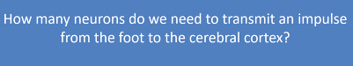
Like a tattili impulse.

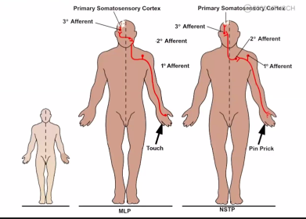

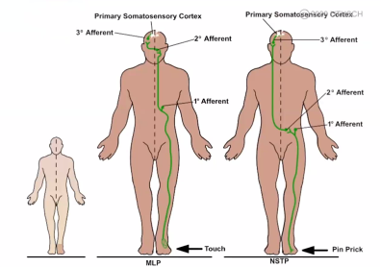

In our perfiety we have specific receptor to collect data

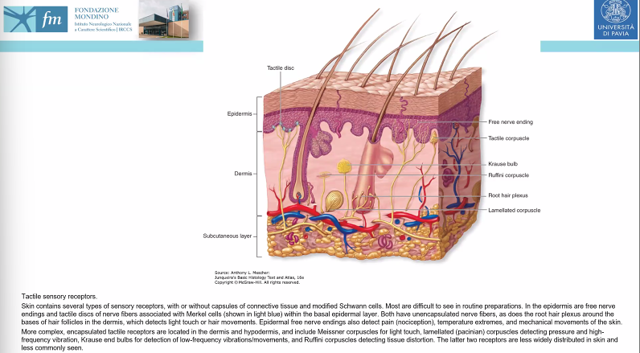
SKIN
outer layter (epidetmis)

We have some specific structure that are all different

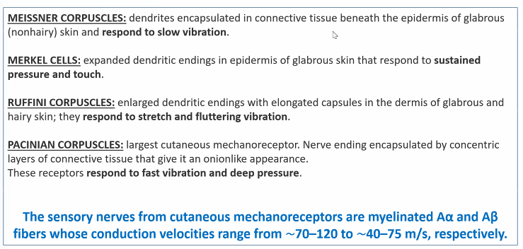

Each of these structure are create to respond to specific stimuli

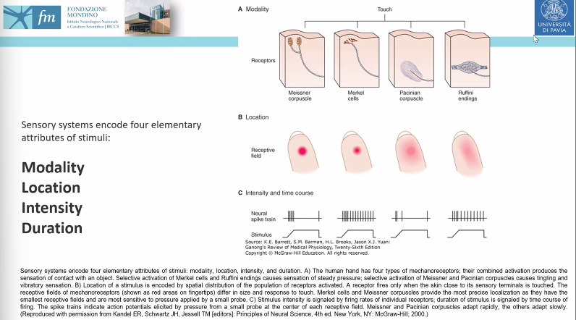
We have many things to discuss
- Modality: each specific receptor is made to transmit and decode a specific sensory modality
- Location: where the stimuli is applied
- Intensity: elaborated in the periphery
- Duration:

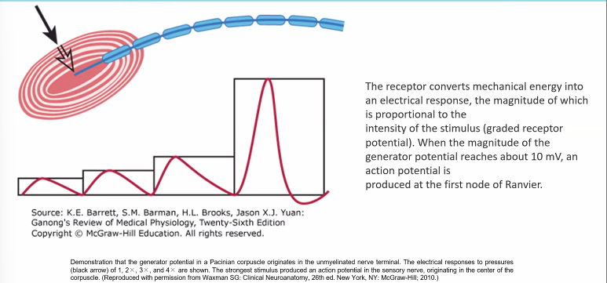

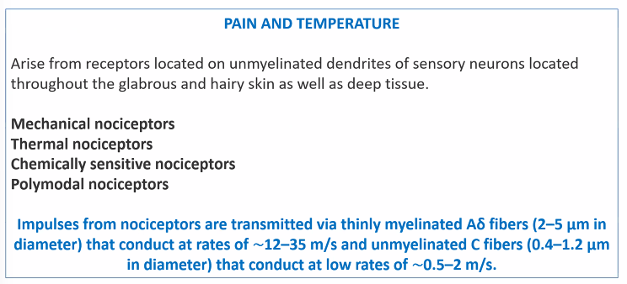
We have pain and temperature to decode. We do not have specific receptor but peripheral ending

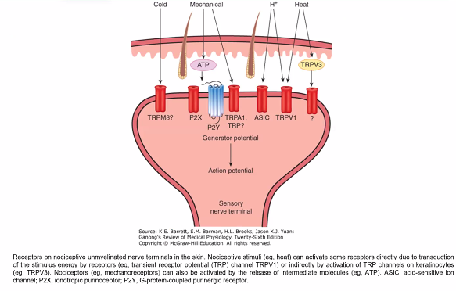
specific channels in nerves ending

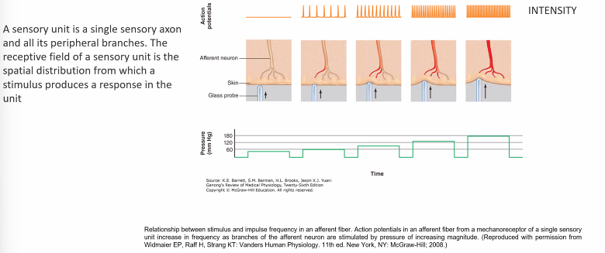

if we go on with the stimulation we can activia the complete nerves ending

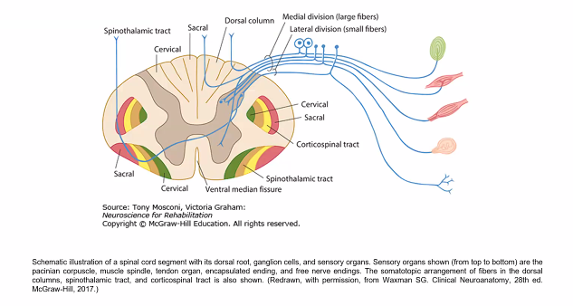
Right: all receptors and ending

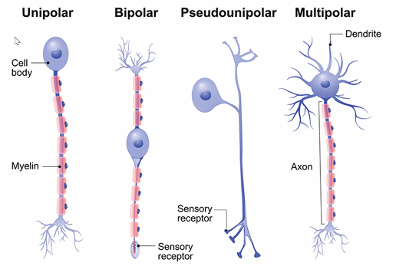

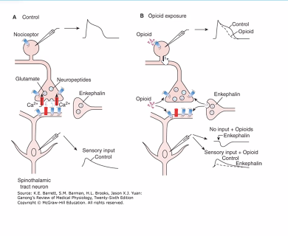

2 different pathways. Provide tattile sensation


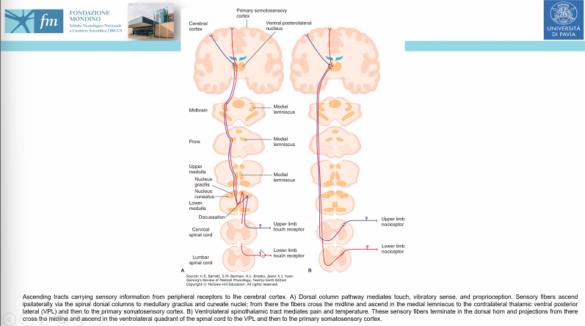
Two specific different ways

In the medulla after connection with secondFamous to the sensory Coolpix.right side we have the way that we call spino spino talamo corticale way that's because we have non si seppe information we have connection with the second numerosi

Altogether and the only things I would like to tell you is that the the in the in the brain and embrace them the line connecting the tactical sensation are called medium middlemiss cuz this is probably an older name.But today we still are using it.The tactile sensation are provided if she later in the spinal cord and are they come up in the spinal for the in the dorsal column while all pain and temperature sensation or control. After all that's the side of the body even in the spinal cord and it's in the latter part.In this slider I had only one one things, couple of things. That is all the pathway.that they showed you are made for the sensation from the body while in the face all the director pay sensation are decoded from pilot regional nervous that regional

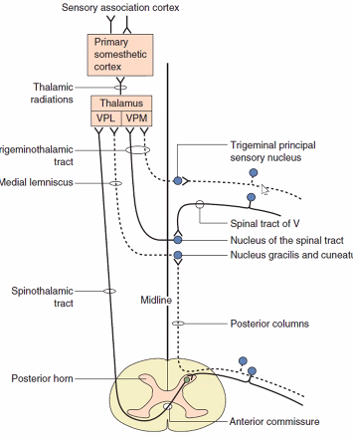

----

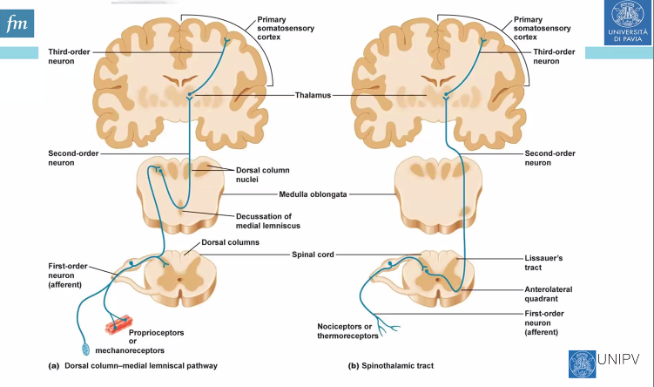
dorsal column pathway on the left.

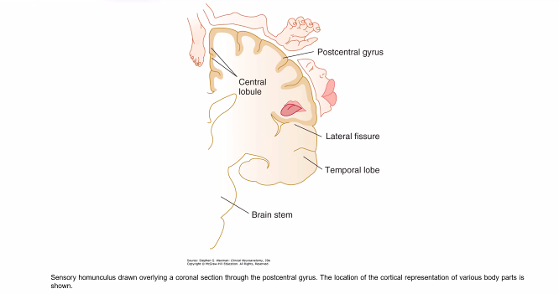
Centar umulculus

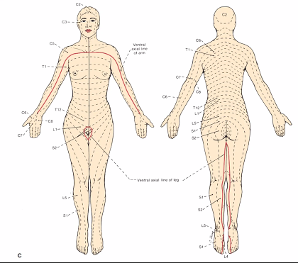

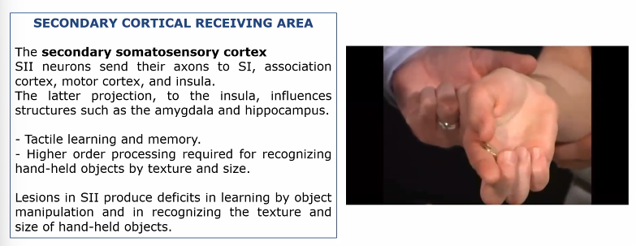

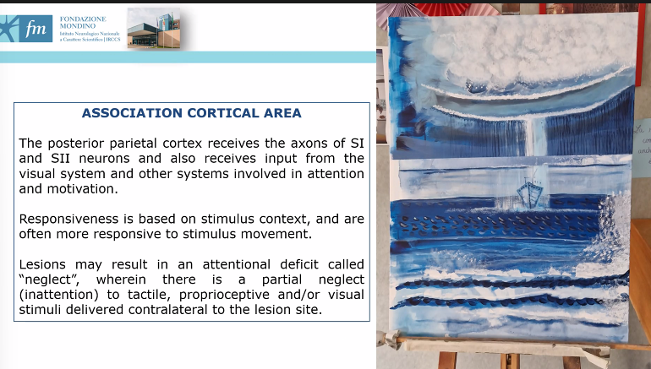
lesion associative cortical area, typuicial damage in right emisphere ⟹ left neglect

painting by a patient in Mondino

everything is drawn on the right side of the picture. If we aked the patient if it is asymmetrical? for the patient it is centered in the middle.

patient can not recgonise its own deficit.

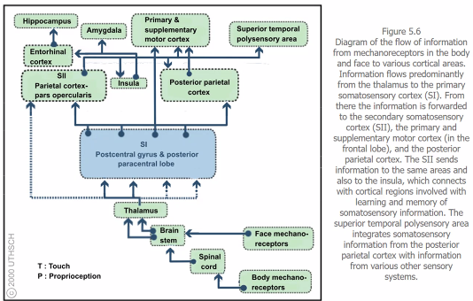


We can control pain

----

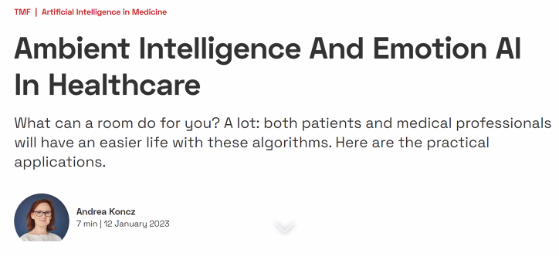
provide better healthcare at home for the patient.

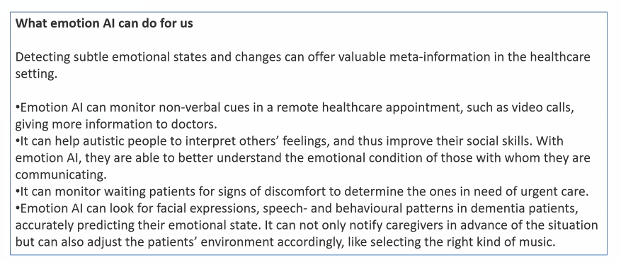
Now we can perfrom remote evaluation

We can monitor the patient and send allarm if they need care urgent

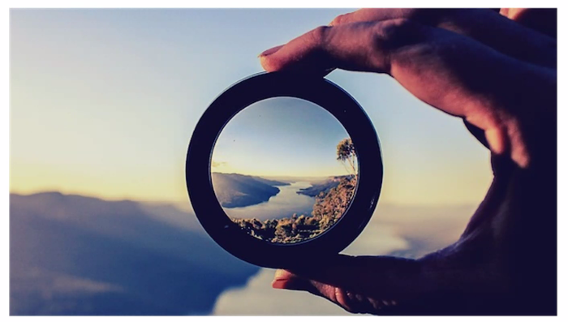

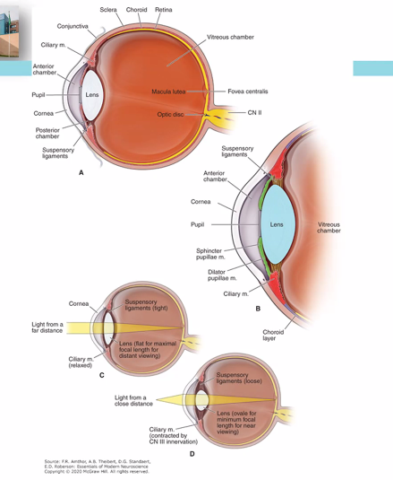
retina: where images are captured. Retina in back part of the eye. focus the lights in specific parts. All the images are called but only a small part collect the information

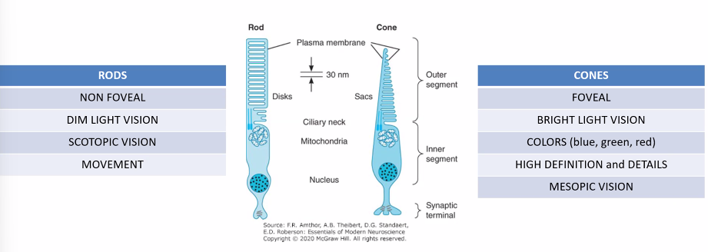
rods: perfiveral part: meant to provide dim light vision

Cones: placed only in the fovaal, for bright light
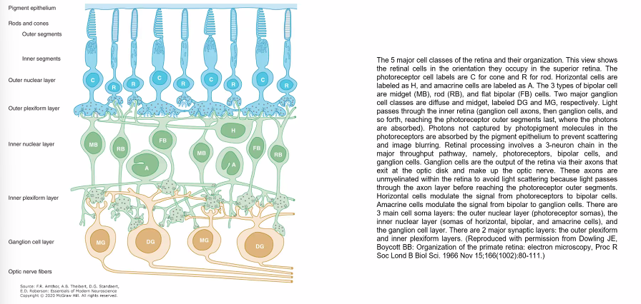

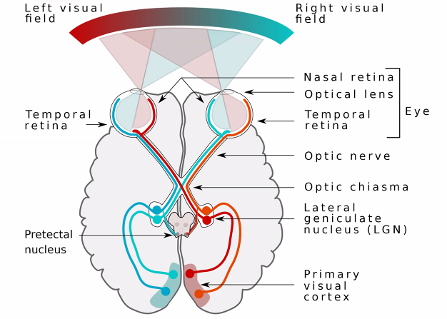

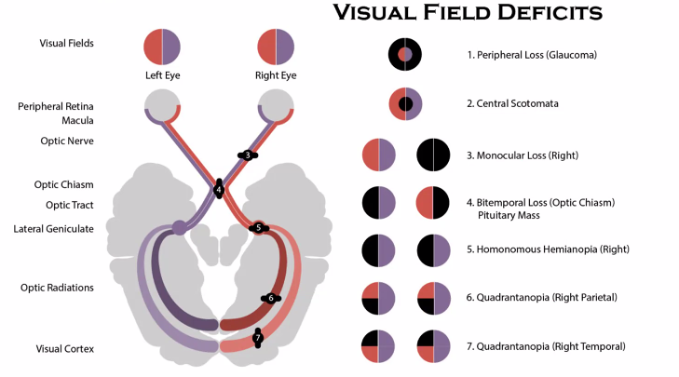

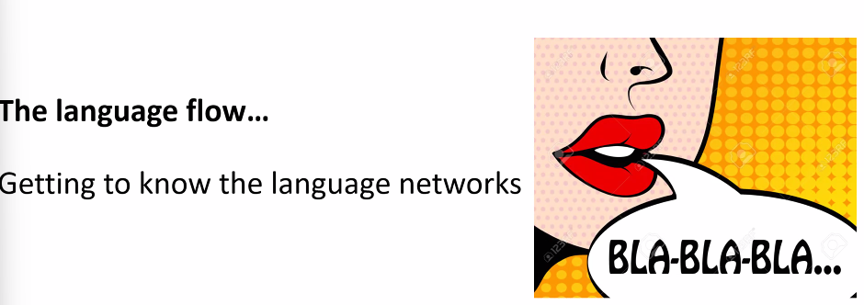

language

